Development and Gender Differences of Static Postural Control in Indian Children between 3 to 15 Years using the mCTSIB
Dr. Priya Chitre¹, Dr. Hutoxi Writer²
¹Lecturer, MAAER’S Physiotherapy College, Talegaon Dabhade, Pune, India
²Professor and HOD, Physiotherapy School and Centre, Topiwala National Medical College, Mumbai, India
Abstract: To study age-wise development and gender differences of static postural control in Indian children between 3-15 years using mCTSIB
Methodology: 260 children, between ages of 3-15 years, were divided age wise into 13 groups, each group having 10 boys and 10 girls. They underwent analysis of postural sway velocity under 4 different conditions using the mCTSIB test on Neurocom Balance Master.
Mean sway velocity of each group was compared to adult values and between genders for age-wise and gender-wise differences.
Results: Unpaired t-test showed no statistically significant difference (p>0.05) between sway velocity in children and adults at following ages. Eyes open on force plate-13 years and beyond; Eyes closed on force plate- 10 years & beyond; Eyes open on foam-15 years & beyond; Eyes closed on foam-8 years & beyond
There was statistically significant difference (p<0.05) with girls being better than boys at ages 5 and 9 in condition 3 and 4 of mCTSIB
Conclusion: Adult levels of postural sway are reached at age 13 years when all 3 sensory systems i.e. visual, vestibular, somatosensory act. Adult levels reached at 10 years when Vestibular and somatosensory system act, 15 years when visual and vestibular systems provide more information, 8 years when only vestibular system acts
At ages 5 and 9, girls are significantly better than boys under challenging sensory conditions
Clinical Significance: Basis for age-appropriate balance testing and exercise.
Keywords: Postural Control, mCTSIB, sway velocity.
- Introduction
Postural control is defined by Shumway-Cook and Woollacott [1] as the ability to control the body's position in space for the combined purposes of stability and orientation. It involves the ability to use sensory information about position and movement of body in space to changing task and environmental conditions. It requires a complex interaction of musculoskeletal components including joint range of motion, flexibility, muscle properties as well as neural components such as neuromuscular response strategies, sensory processes including visual, vestibular and somatosensory systems, sensory strategies, internal representation mapping sensation to action and last but not the least higher level processes for adaptive and anticipatory aspects of postural control. [1]
Postural Control in quiet stance or static postural control is defined as the ability to maintain the projected Centre of Mass (COM) within the limits of the base of support (BOS). [1] The CNS must organise information from sensory receptors throughout the body before it can determine the body’s position is space. The visual, vestibular and somatosensory system each provide a ‘frame of reference’ for postural control.[2] Sensory strategies, that is, the relative weight given to a sense vary as a function of age, task and environment.[1],[3],[4]. Assessment of how the Central Nervous System adapts multiple sensory inputs for the purpose of postural control can be done by measuring the body sway under different sensory conditions such as eyes open or eyes closed on a firm and foam surface.[3]. The Centre of Pressure (COP) is a commonly used output measure of the postural control system, the trajectory of which can be obtained using a force plate. Though several clinical tests are available to assess balance control, the force platform provides an objective measurement of postural control. Based on the literature review, the number of studies reported on children utilising force platforms seem to be low in India.
There have been several studies over the years examining the changes in spontaneous sway with development with varying results. Schlotz A W, in 2005 [5] investigated the sway velocity under three visual conditions(eyes open, blindfolded and sway referenced visual enclosure) and concluded that proprioceptive function seemed to mature at 3to 4 years of age whereas visual and vestibular systems reached adult level at 15 to 16 years. However, Sparto PJ, in 2004 [6] had stated that 7-12 year old children do not utilise somatosensory cues to the same extent as adults when visual and somatosensory cues are conflicting. Rival C in 2004 [7] suggested that processes underlying optimum postural stability are mature as soon as 6 years of age after measuring Centre of Pressure on a force plate. Though, in his study on 74 female and 80 male children using the Sensory organisation test (SOT), Peterson M L, in 2005 concluded that children do not demonstrate adult-like use of sensory information prior to the age of 12 years. [8] A recent literature review on postural sway in children concluded that considerable disagreement exists development of postural sway in children and that future research is necessary to determine for which age groups age-specific reference values are relevant. [9]
Understanding age-related postural control can serve as the basis for determining best therapeutic approach for children with related balance disturbances and hence the need of the study. The aim of the present study was to determine age at which postural sway reaches adult values under different sensory conditions in Indian children between the age of 3 to 15 years and if gender differences exist in the same, using the mCTSIB. The mCTSIB is a modification of the original CTSIB or foam and dome test and adds objective analysis of the patient’s functional balance control to quantify postural sway velocity during the following four sensory conditions
- Eyes Open, Firm surface- It tests all available sensory feedback systems, i.e. Visual, vestibular and somatosensory
- Eyes Closed, firm surface- It tests the effectiveness of the closed loop postural control system without visual feedback
- Eyes Open, Foam- It examines how well the system resolves proprioceptive-visual and/or proprioceptive-vestibular conflicts
- Eyes Closed, foam- It tests how well the system controls posture with just vestibular feedback
2. Methodology
Study design: Normative.
Sample size and population: 260 normal children between 3-15 years. 20 adults between 20-35 years. The age group was selected as children below 3 years do not follow commands efficiently, have decreased attention span and would have difficulty maintaining quiet standing position required for the mCTSIB. Most studies have concluded that adult like postural control is achieved by children by 15 years of age, hence the upper limit.
Sampling technique: Purposive sampling.
Inclusion criteria: Normal healthy children. Normal healthy adults.
Exclusion criteria: Premature birth, delayed milestones, cerebral palsy, learning disability, illness in past 3 months, obesity, malnourishment, visual deficits, gymnastics.
Outcome measure: Postural sway velocity with mCTSIB using the Neurocom Balance Master.
Data Collection and Analysis: 260 children were divided age-wise into 13 groups between ages of 3-15 years, each group having 10 boys and 10 girls of that age. Parents and teachers had to sign a consent form and student information sheet respectively. Materials used were height chart, measuring tape and Balance Master. Subject’s height and birth date were fed into the Balance Master system. The children were explained the entire procedure and a trial was taken to ensure their understanding. For both the children and adults, 3 trials each of 4 different conditions were performed with every trial lasting for 10 seconds.
Condition 1: Eyes open, Force plate (Fig.1)
Condition 2: Eyes closed, Force plate
Condition 3: Eyes open, Foam (Fig.2)
Condition 4: Eyes closed, Foam
To measure the sway velocity, the subject was made to stand on the force plate/foam with feet apart in such a way that the medial malleoli lie along the horizontal line marked on the force plate/foam, the toes touch the square markings made on the force plate/foam and the heels touch the T, M, S line as prompted by the system based on height. (Fig. 3)
The computer automatically obtained the sway velocity in degrees/second for 3 trials in each sensory condition and an average velocity after 3 trials. Also, a composite sway velocity averaged over 12 trials was obtained.
20 adults were also assessed for their postural sway velocity in 4 different sensory conditions. The Balance Master system has adult normative values for reference too. Mean sway velocity of children was compared to adult values for age-wise differences. Boys and Girls were also compared in each condition of the mCTSIB.
Statistical test: Unpaired t-test was used to find if statistical significance in sway velocities existed between children at each age and adults and also between boys and girls in the 4 conditions.
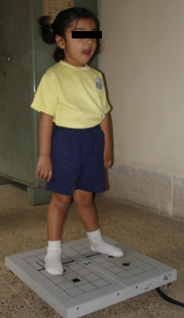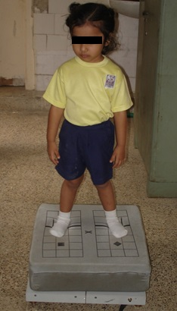
Fig. 1 Fig. 2
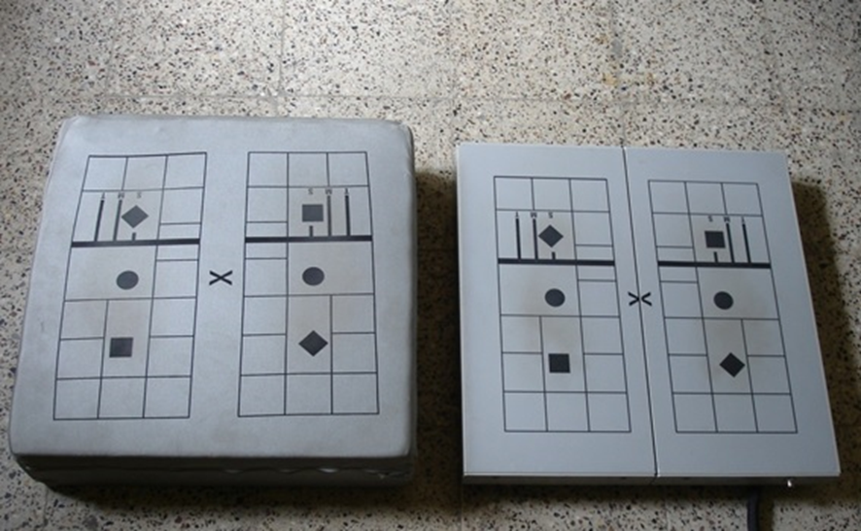
Fig.3
3. Results
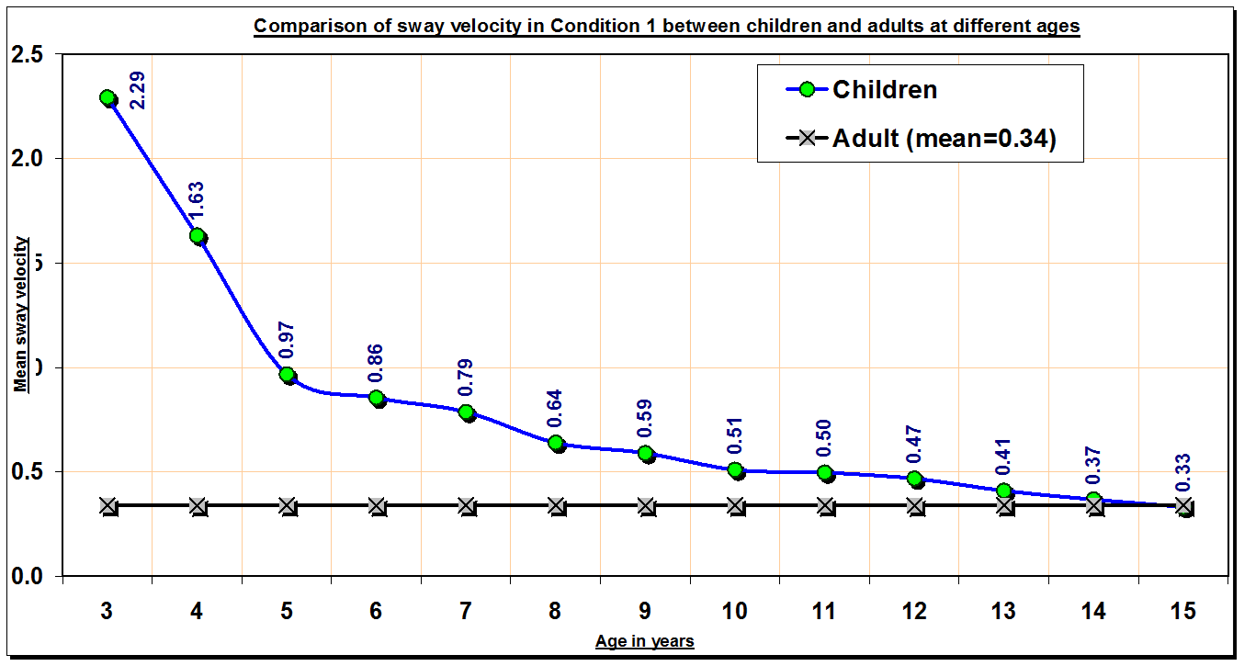
GRAPH 1
Graph 1 shows the comparison of sway velocity in condition 1 of the mCTSIB between children at different ages from 3-15 years and adults. X axis represents the age in years and Y axis represents the mean sway velocity in degrees/second. The mean adult sway velocity is 0.34 degrees/second. There is a marked decrease in sway velocity from 3-6 years. Beyond 6 years there is a gradual decrease in sway velocity, with it reaching closer to adult values at 13 years (0.41 degrees/second) and beyond.
Table I- Comparison of mean sway velocity in Condition 1 between adults and children at different ages
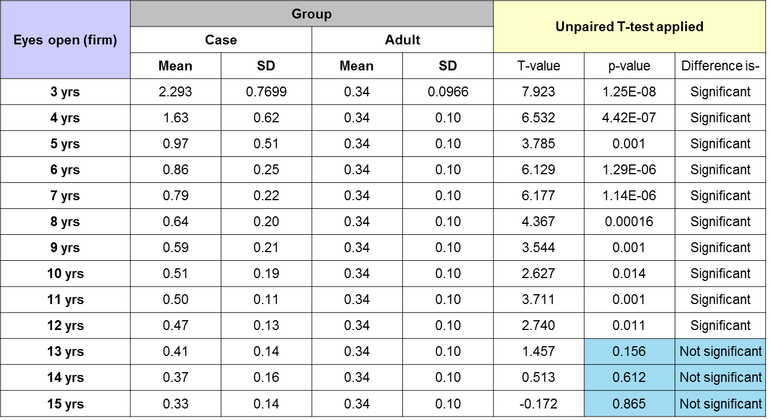
Table I shows the mean sway velocity of adults in condition 2 of mCTSIB i.e. Eyes closed on force plate, is 0.34 degrees/second. It is seen that there is statistically significant difference in sway velocity up to the age of 12 years. (p<0.05 i.e 0.011) There is no statistically significant difference in the sway velocity of children from the age of 13 years to 15 years. (p>0.05)
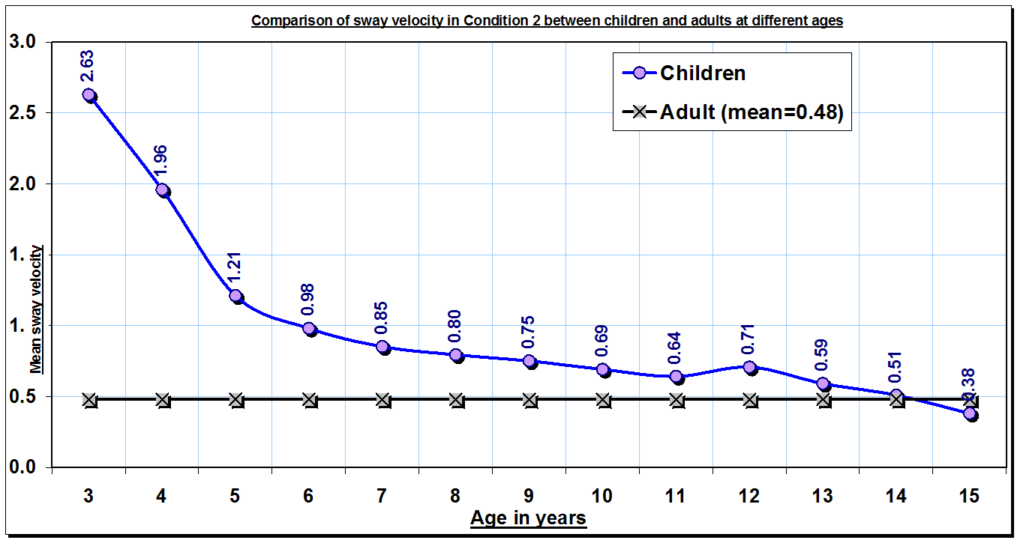
Graph 2
The above graph 2 shows that there is a marked decrease in sway velocity from 3 to 6 years of age with the sway velocity at 3 years being 2.63 degrees/second and at 6 years being 0.98 degrees/second. Beyond 6 years there is a gradual decrease in sway velocity, with it reaching closer to adult values (closer to 0.48 degrees/second) at 10 years (0.69 deg/sec) and beyond.
Table II- Comparison of sway velocity in Condition 2 between adults and children at different ages
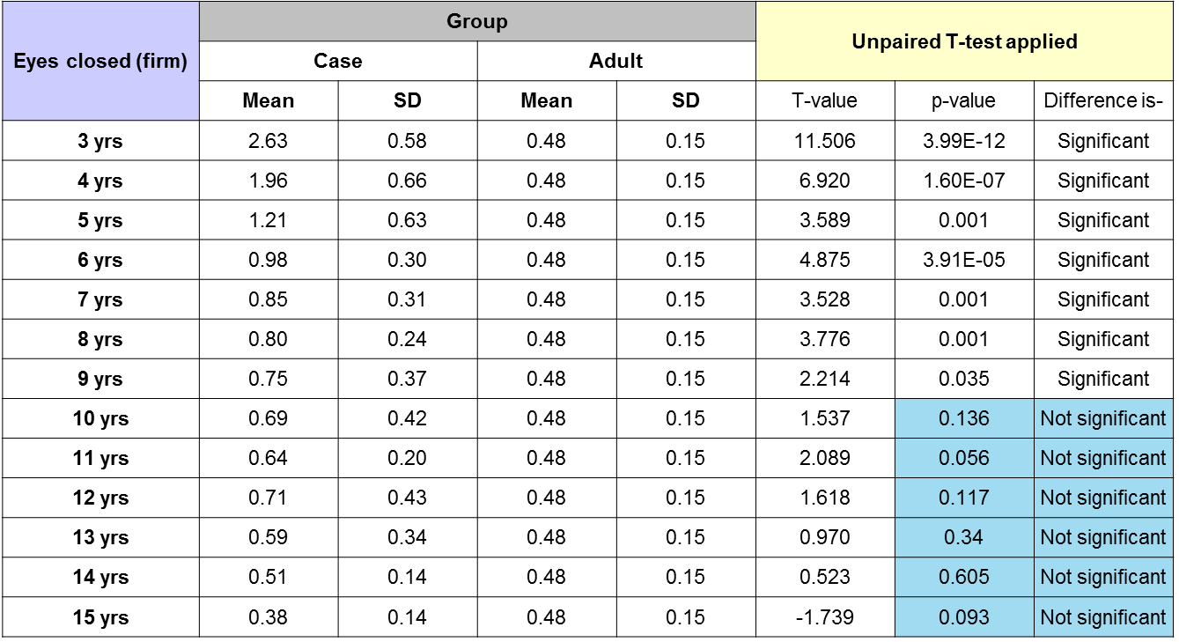
Table II shows statistically significant difference in sway velocity up to the age of 9 years. (p<0.05) From the age of 10 years and beyond there is no statistically significant difference between adult and children sway velocity.
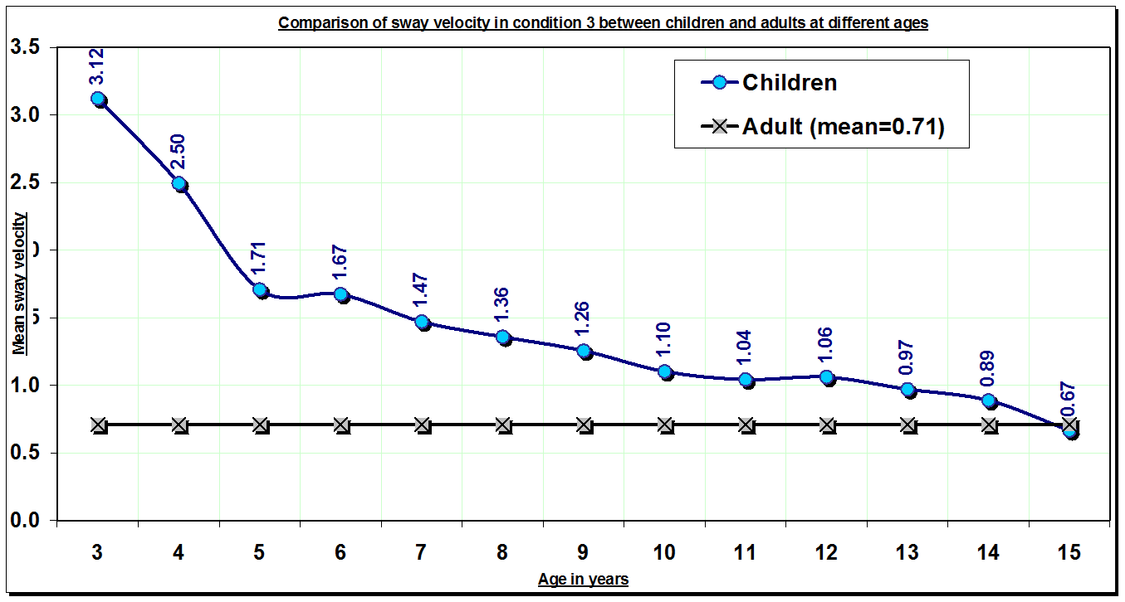
GRAPH 3
Graph 3 shows mean adult sway velocity at 0.71 deg/sec. There is a marked decreae in sway velocity from 3 to 5 years of age. At 3 years the mean sway velocity is 3.12 deg/sec and at 5 years it is 1.71 deg/sec. Beyond 5 years there is a gradual decrease, with sway velocity reaching closer to adult values at 14 years (0.89 deg/sec) and beyond.
Table III- Comparison of sway velocity in Condition 3 between adults and children at different ages
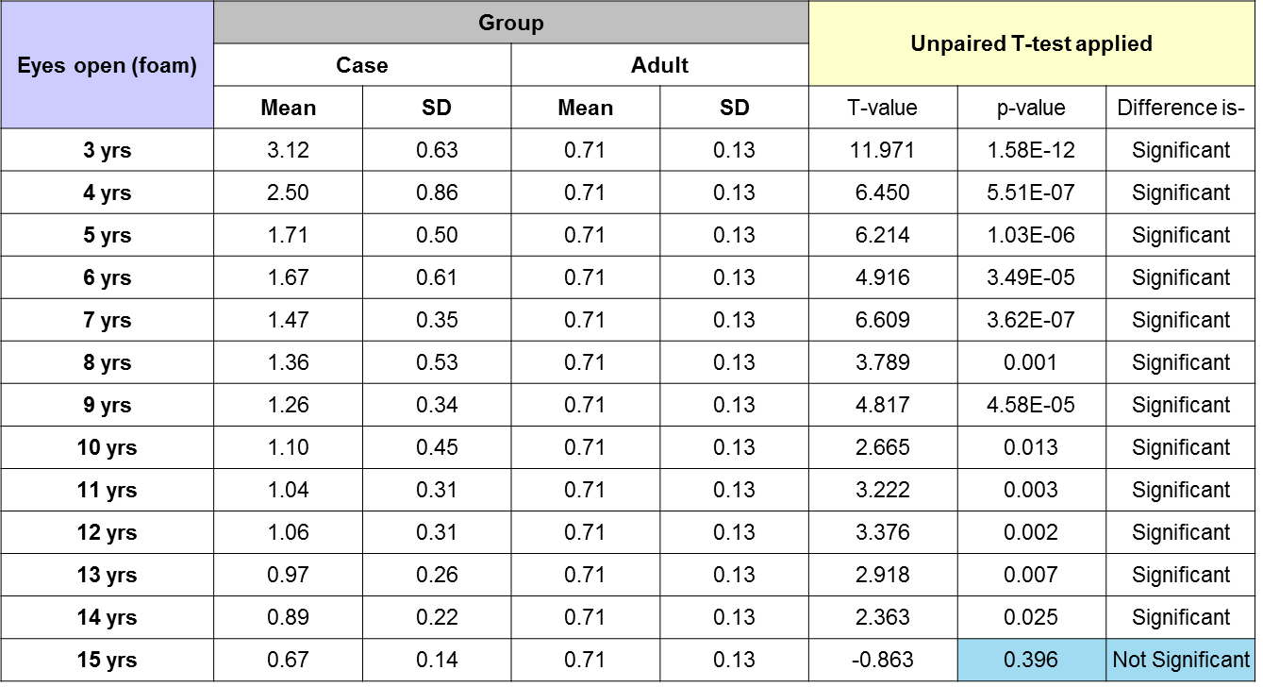
Table III shows statistically significant difference in sway velocity upto the age of 14 years. (p<0.05). There is no statistically significant difference in sway velocity of children and adults in condition 3 at the age of 15 years.
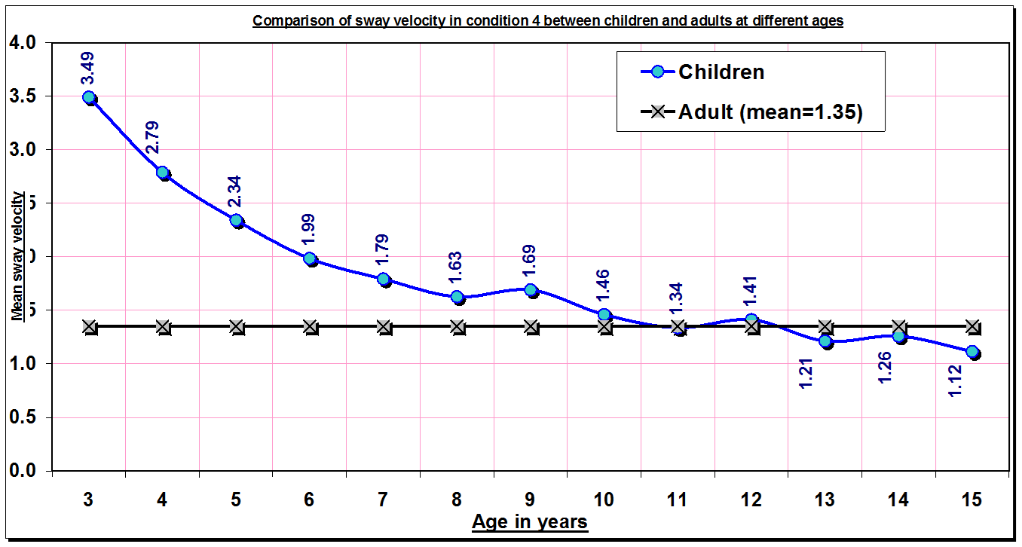
GRAPH 4
Graph 4 shows mean adult sway velocity is 1.35 deg/sec in condition 4 of mCTSIB i.e. eyes closed on foam. There is amarked decrease in sway velocity from 3 to 6 years of age with the sway velocity at 3 years being 3.49 deg/sec and at 6 years being 1.99 deg/sec. Beyond 6 years there is a gradual decrease with it reaching closer to adult values at 8 years (1.63 deg/sec) and beyond.
Table IV- Comparison of Condition 4 between adults and children at different ages
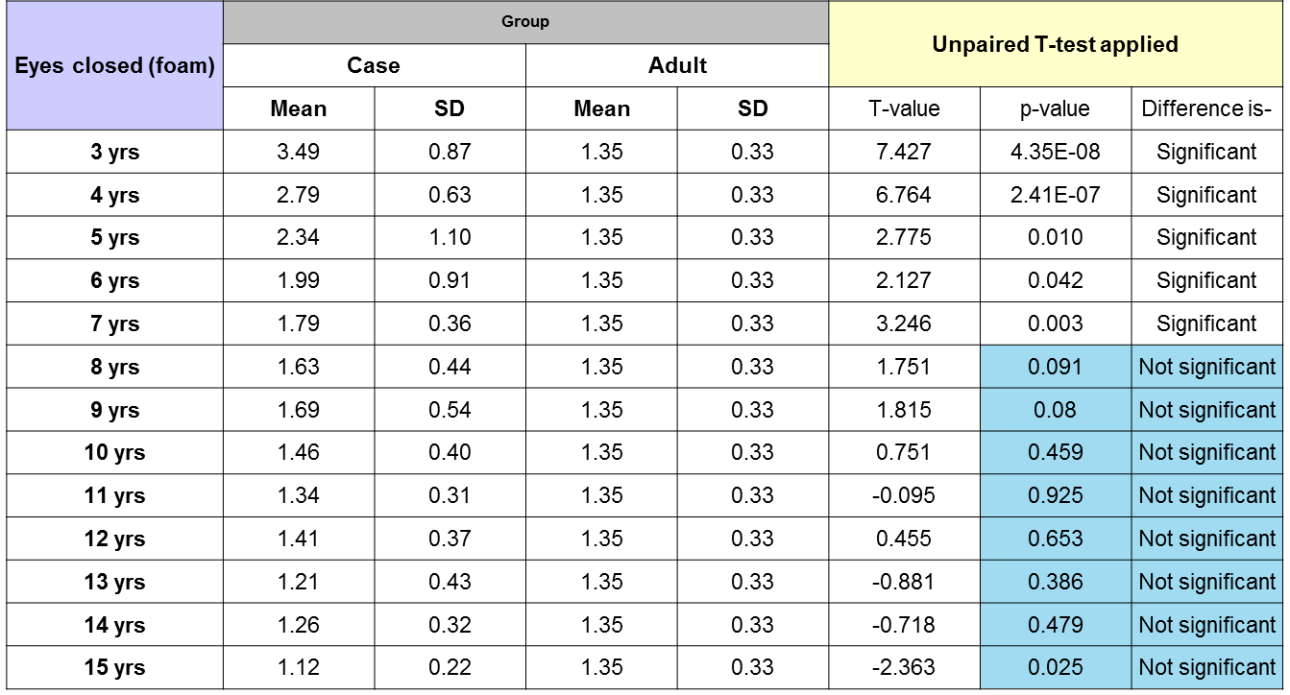
Table IV shows that there is a statistically significant difference in sway velocity between children and adults up to the age of 7 years. From the age of 8 years to 15 years there is no significant difference. (p>0.05)
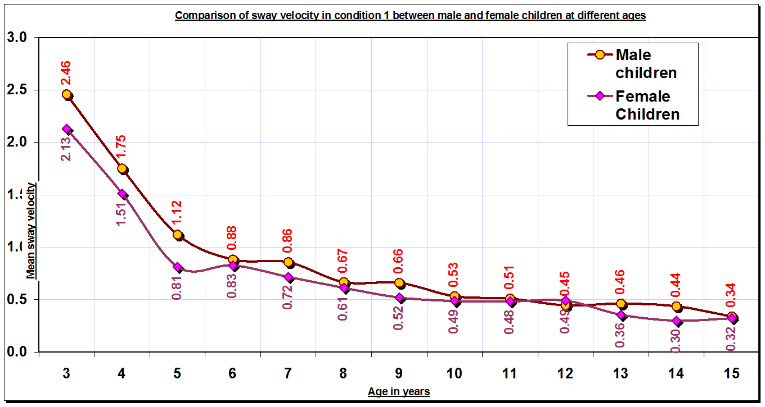
GRAPH 5
Graph 5 shows the comparison of sway velocity in condition 1 of mCTSIB between boys and girls. At every age the female child has a lower value of sway velocity than their male counterparts. The mean sway velocity of females at age 3 is 2.13 deg/sec and male children is 2.46 deg/sec. At 15 years, it is 0.32 deg/sec and 0.34 deg/sec for female and male children respectively.
Table V- Comparison of Condition 1 between boys and girls at different ages
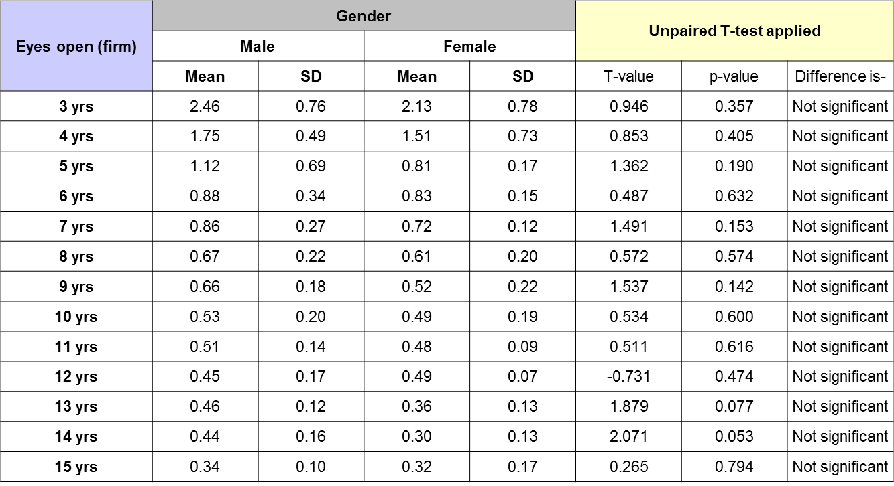
Table V shows that on comparison of mean sway velocity of male and female children at different ages in condition 1 of mCTSIB, there is no statistically significant difference between them.
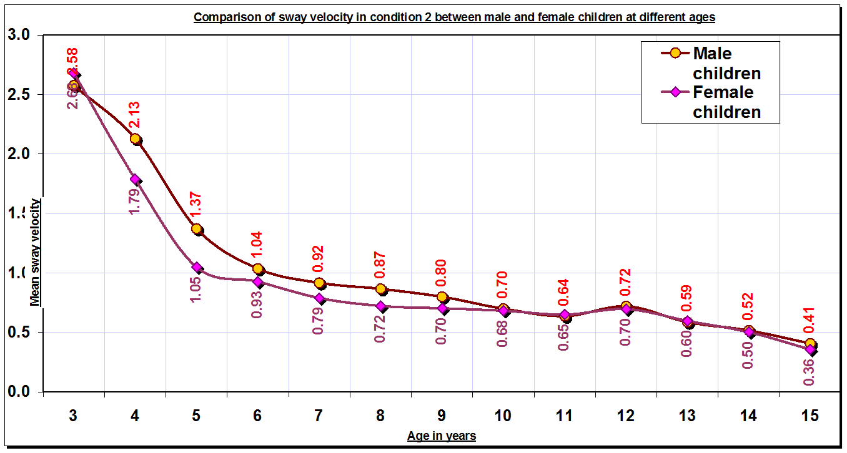
GRAPH 6
Graph 6 shows comparison of mean sway velocity between male and female children in condition 2 of mCTSIB. At 3 years the mean sway velocity of female and male children is 2.63 deg/sec and 2.58 deg/sec respectively. At 15 years it is 0.36 deg/sec and 0.41 deg/sec for female and male children respectively. Female children had a lower sway velocity than male children at almost all ages.
Table VI- Comparison of Condition 2 between boys and girls at different ages
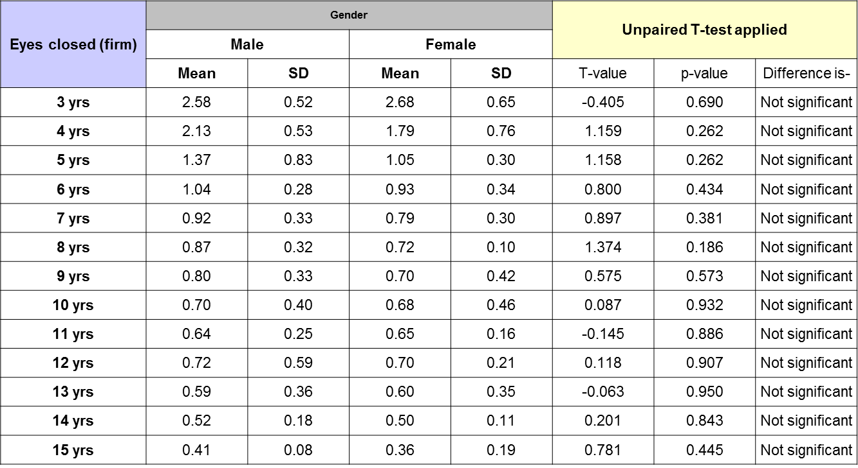
Table VI shows that on comparing mean sway velocity between male and female children at different ages, there is no statistically significant difference in condition 2 of mCTSIB.
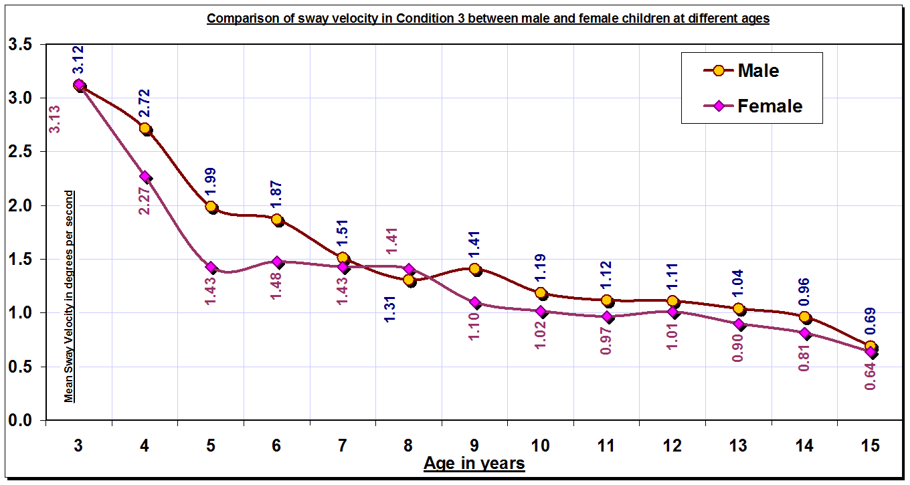
GRAPH 7
Graph 7 shows the comparison of mean sway velocity of boys and girls at different ages in condition 3 of mCTSIB i.e. eyes open on foam. Female children had lower sway velocity than their male counterparts at almost all ages.
Table VII- Comparison of Condition 3 between boys and girls at different ages
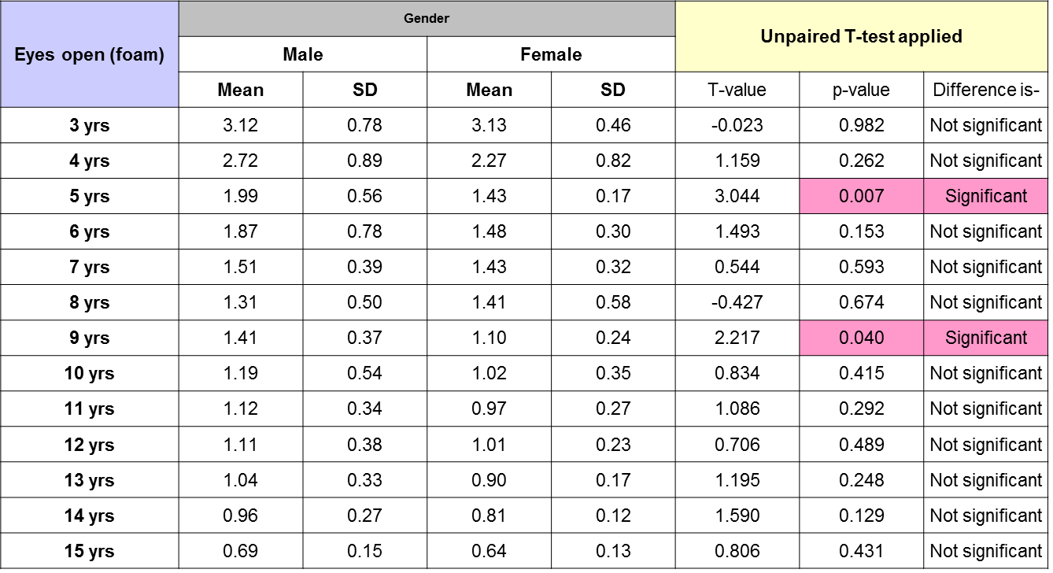
Table VII shows that on comparison of mean sway velocity in condition 3 of mCTSIB, there is a statistically significant difference between boys and girls at age of 5 and 9 years, with girls being closer to adult values than boys.
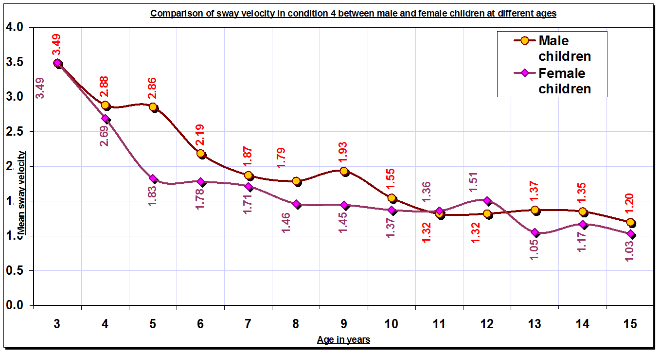
Graph 8
Graph 8 shows the comparison of mean sway velocity in female and male children at different ages in condition 4 of mCTSIB i.e. eyes closed on foam. Female children have lower sway velocity than male children at all ages except 11 and 12.
Table VIII- Comparison of Condition 4 between boys and girls at different ages
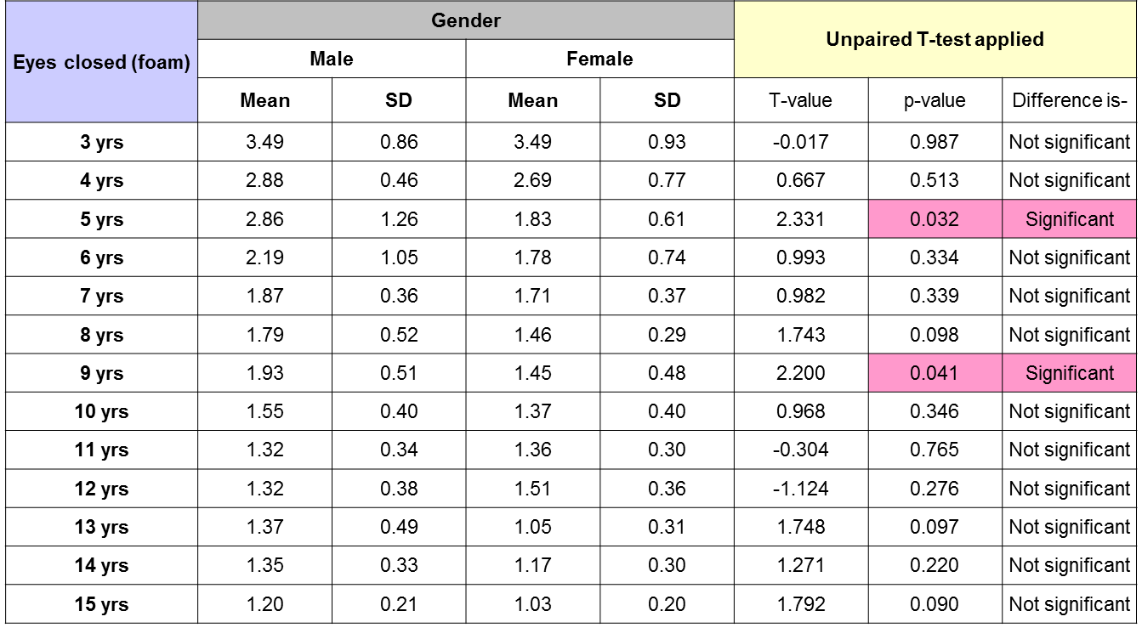
Table VIII shows that there is a statistically significant difference in sway velocity of male and female children at age 5 and 9 years in condition 4 of mCTSIB.
4. Discussion
The data derived from the study was assessed to compare the sway velocity between children at different ages from 3 to 15 years and adults in 4 conditions of the mCTSIB and between male and female children of different ages in all 4 conditions.
From Graphs 1 to 4 it was seen that as age increases the sway velocity decreases in all conditions of the mCTSIB. The decrease in sway was more marked in the age group of 3 to 6 years, after which there was a gradual decline. E.g. At 3 years, for condition 1 the sway velocity was 2.29 deg/sec, at 4 years it was 1.63 deg/sec, at 5 years it was 0.97 deg/sec, at 6 years it was 0.86 deg/sec. Beyond this, the decrease in sway velocity was gradual from 0.64 at 8 years to 0.33 deg/sec at 15 years.
Researchers studying the development of balance have found that transition from immature to mature responses is not linear but stage-like with the greatest variability occurring in the 4-6 year old children. It was proposed that this age is a transition period in the development of postural control [10]. At this time the nervous system uses visual-vestibular input to fine tune ankle joint proprioception in preparation for its increased importance in postural control and fine tunes the structural organization of the postural synergies themselves. [1], [11]
Usui N stated that the upright postural sway decreased markedly between the ages of 3 to 6 years and then slowly after the age of 6 years which is also seen in above study. [12] Shambes GM while studying postural control in children aged 4 to 8 years showed that 8 year old children showed less postural sway and more definitive muscular localization and that there was a marked decrease in postural sway from 4 to 7 years. [13] This marked decrease can be attributed to the maturation of the central nervous system. [14], [15] The mapping of individual senses to action and mapping of multiple senses to action which helps in creating internal representations necessary for coordinated postural abilities, develop up to the age of 6 years[11] along with a continuous development of multiple sensory and motor systems.
It has been suggested, that adaptive capabilities that allow the child to modify sensory and motor strategies to changing task and environmental condition are developing the most up to the age of 6 years and that discontinuous changes seen in the development of postural control may be the result of critical dimensional changes seen in the body of the growing child. [10] The Centre of gravity is higher in younger children and moves lower as the ratio of trunk to limbs and head size to body size changes. Also, the center of pressure changes along the plantar arch.
Beyond the age of 6 years, as the child becomes more active in sports, starts schooling, he is exposed to a variety of environment thus enriching his sensory motor experiences. Between the ages of 7 to 15 the child comes closer to adult values of postural control.
From Graph 1 and Table I it is seen that under normal conditions of quiet stance, children reach adult like level of postural sway by the age of 13 years, Thus when all 3 sensory systems provide accurate information, children are comparable to adults at 13 years and beyond. This is supported by study done by Hayes et al which states that the spontaneous sway in children reach adult like levels by 9-12 years of age for eyes open conditions. [16]
From Graph 2 and Table II it is seen that when visual feedback is absent, the effectiveness of the closed loop postural control system reaches adult levels by 10 years of age, suggesting that vestibular and somatosensory system contribution to static postural control seems to develop to adult levels by 10 years. As children do not reach adult levels in condition 1 until 13 years of age which is later than in condition 2, we can infer that visual system contribution to postural control becomes more effective at a later age. Peterson ML has also suggested that children under 11 years do no use visual information as effectively as adults [8]
From Graph 3 and Table III it is seen that with inaccurate proprioceptive input, when visual and vestibular system work, children become as effective as adults in resolving proprioceptive-vestibular conflict and proprioceptive-visual conflict by 15 years of age.
From Graph 4 and Table IV it is seen that children have adult like ability to resolve proprioceptive- vestibular conflicts with absent visual feedback by 8 years of age. In this condition, the vestibular system may contribute to maintenance of static postural control suggesting that at 8 years, vestibular system contribution to balance reaches adult values. This also supports our inference of visual system contribution to postural control by 13 years and beyond, as in condition 3 children get both visual and vestibular input but reach adult values at a later age.
Assainte and Amblard have suggested that from the age of 7 to 8 years onwards, information specifying the head position relative to support surface becomes progressively more available to the equilibrium control centers. At around 7-8 years, there is a transient predominance of dynamic vestibular contribution to balance and lowering of visual contribution to balance. [17], [18], [19]
Overall, our results are supported by the study done by Sparto PJ who suggested that the ability to utilize individual senses when other senses are conflicting continues to develop until 12-13 years of age. [6]
From Graphs 5 to 8 when mean sway velocity of male children and female children was compared, it is seen that in condition 1 and 2 where proprioceptive information is correctly available, girls have a lower sway velocity than boys though the difference is not significant. In condition 3 and 4 there was a statistically significant difference in sway velocity of the male and female children at 5 and 9 years of age with females having lower sway values.
It is proposed that, in females the corpus callosum is broader than in males and its myelination occurs at an earlier age. [20], [21]
The ability to organise information for balance and bilateral coordination seems to be better in girls than in boys. Also, with their leaner body and wider pelvis giving a better base of support, girls may be better than boys where balance is concerned. [5], [22]
According to research, around the age of 5 years there is a period of transition where somatosensory system starts showing its dominance and the child needs to re learn the motor strategies associated with balance. [1] Girls might be better equipped to deal with this change showing significantly better static control than boys where support system information is not correctly available. Around 9 years of age, as puberty begins, physical dimensions begin to change. Males tend to get top heavy thus riding the COG upwards which may contribute to more sway.
- Conclusion
While studying the development of static postural control in children between 3 to 15 years, marked decrease is seen in the postural sway velocity between the ages of 3-6 years in all conditions of the mCTSIB, which marks a period of transition in the development of postural control.
In condition 1, eyes open on force plate, when all 3 sensory systems provide information regarding the body’s position in space, the difference in mean sway velocity between children and adults is non-significant at 13 years and beyond. In condition 2, eyes closed on force plate, when vestibular and somatosensory system provide information, the difference in sway velocity between children and adults is non-significant at 10 years and beyond. In condition 3, eyes open on foam, when visual and vestibular system provide information children are closer to adult values at 15 years of age. In condition 4, eyes closed on foam, the difference in sway velocity between children and adults in non-significant at 8 years and beyond. Vestibular system contribution to balance becomes adult like around 8 years of age.
Female children have a lower sway velocity than male children with significant difference at 5 and 9 years in conditions where support system information is not accurately available.
Results of this study can be used to design balance treatment protocols for children with emphasis on different systems at different ages based on the system development and contribution to balance. The ‘Sensory Organisation Test’ can be done to find out the individual system contribution to balance on a larger sample size.
REFERENCES
- Shumway-Cook Anne and Woollacott Marjorie, ‘Motor Control-Translating Research into Clinical Practice’, Third edition, Lippincott Williams and Wilkins, pp.157-189, 2007
- Gurfinkel VS and Levick YS, Perceptual and automatic aspects of postural body scheme, Paillard J, ed. Brain and Space, New York, Oxford Science, 1991
- Nashner LM, ’Sensory, Neuromuscular and biomechanical contributions to human balance, Duncan P, ed. Balance: Proceedings of the APTA forum. Alexandria, VA: American Physical Therapy Association, pp. 5-12, 1989
- Oie KS, Kiemel T, Jeka JJ, ‘Multisensory fusion: simultaneous re-weighting of vision and touch for control of human posture, Cogn Brain Res, 14:164-176, 2002
- Schlotz AW, Effect of age and sex on maturation of sensory systems and balance control: Dev Med Child Neurol, 48(6):477-82,Jun 2006
- Sparto PJ, Influence of dynamic visual cues for postural control in children: Exp Brain Res; 168(4); pp. 505-16, Jan 2006
- Rival C, Developmental changes of static standing balance in children: Neuroscience Letter, 376(2):pp. 133-6, March 2005
- Peterson ML, Sensory Integration during balance: Gait Posture; 23(4): pp.455-63, Jun 2006
- Verbecque E, Vereeck L, Hallemans A, Postural sway in children: A literature review, Gait Posture. 2016 Sep; 49:402-10,2016
- Kugler PN, Kelso JAS, Development of movement control and coordination, Wiley, pp. 5-78, New York, 1982
- Shumway-Cook A1, Woollacott MH, The growth of stability: postural control from a development perspective. J Mot Behav.;17(2):pp.131-47, Jun 1985
- Usui N, Development of upright postural sway in the normal child: Dev med child Neurol,37(11):985-96, Nov 1995
- Shambes G, Static Postural control in children, American Journal of Physical Medicine, 55(5), pg. 52-221, 1976
- Gallahue D et al, Understanding Motor Development, Infants, Children and Adolescents, 2nd edition, Sydney, 1995
- Hirabayashi S and Iwasaki Y, Developmental perspective of sensory organization on postural control, Brain and Development, 17, pp. 111-13,1995
- Hayes KC, Riach, C, Maturation of postural sway in young children, Dev Med Child Neurol, 29(5), pg. 8-650, 1987
- Assainte C, Development of postural control in healthy children, Neural Plasticity, Volume 12(2-3), 2005
- Assainte, C. and Amblard, B, Peripheral vision and age-related differences in dynamic balance, Human Movement Science 11, pp. 533-548, 1992
- Berger, W. et al, Developmental aspects of equilibrium control during stance, a kinematic and EMG study, Gait and Posture, Volume 3, pp. 149-155, 1995
- Gibson, K.R, Myelinisation and Behavioural Development. A comparative analysis on questions of neoteny, altracity and intelligence, NY, 1985
- Laura S. Allen, Mark F. Richey, Sex Differences in the Corpus Callosum of the Living Human Being, The Journal of Neuroscience, 1 f(4): 933-942, April 1991
- Lockmann JJ and Thelen E, Developmental Biodynamics:Brain, body and behavior connections, Child Develoment, 64(4), pp 953-59, 1993
- Nolan, L, Balance control: Sex and Age differences in 9 to 16 year olds, Dev Med Child Neurol, 47(7), pg. 54-449, 2005
- Hadders Algra M, Development of postural control during the first 18 months of life, Neural Plasticity
Volume 12, Issue 2-3, pp. 99-108, 2005
- Kejonen P1, Kauranen K, Ahasan R, Vanharanta H., Motion analysis measurements of body movements during standing: association with age and sex., Int J Rehabil Res. 2002 Dec;25(4):297-304., 2002
- Kejonen P, Kauranen K, Vanharanta H, The relationship between anthropometric factors and body-balancing movements in postural balance, Arch Phys Med Rehabil. 2003 Jan; 84 (1):17-22
- Maurizio Schmid, Silvia Conforto, Luisa Lopez, Paolo Renzi, and Tommaso D'Alessio, The development of postural strategies in children: a factorial design study, J Neuroengineering Rehabil. 2005; 2: 29.
- Pagnacco G1, Oggero E, Carrick FR. Repeatability of posturographic measures of the mctsib static balance tests: a preliminary investigation, Biomed Sci Instrum. 2008; 44:41-6.

